Resources for an E3Y2 Worship Service

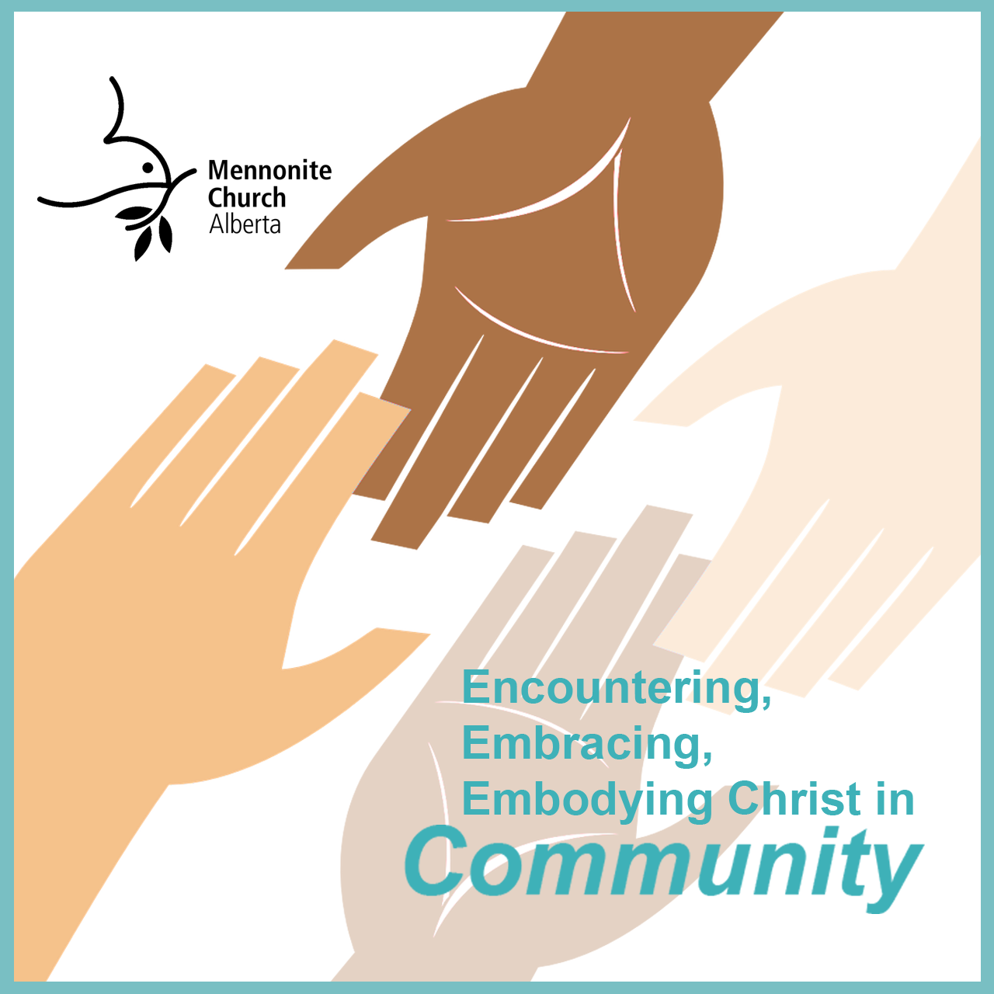
At the province-wide worship service on March 21st MCA launched Year 2 of its Action Plan, Encounter, Embrace and Embody Christ in Community.

MCA is encouraging each congregation to plan a worship service in coming months to focus on this theme. This service could be a time for your congregation to consider this theme more closely, to invite commitment to actions to live out this them, or to use as a refresher service mid-year.

In this document you will find a variety of resources your church could use in preparing for this worship service. By no means are these resources exhaustive nor prescriptive, they are suggestions only.

We begin with a few very basic elements which we believe most churches will want to incorporate into their worship. These are followed by prayers, songs and scriptures that may add to your service. We encourage each congregation to create a time that is uniquely their own while feeling connected with other churches in MCA who are also engaged in a year of growing in community. Use only that which is useful to you.

Near the end of the document are a few ideas for visuals and follow-up activities. Again, these are included as a means of sparking your own direction.

Please, take the time to access the resources available at: https://mcab.ca/e3yeartworesources. They include a bulletin insert, commitment cards, visual graphics, bucket lists of action ideas, and much more.

A Note about Copyright: While the E3 reference group has provided suggestions and resources, it is your responsibility to follow all copyright restrictions and give credit to authors where needed. In this document, the litanies and prayers provided will indicate where they were found. The items which have been composed by the group do not have credits or links listed and are free for you to use without any concerns. The song suggestions reference the hymnals where they are found, which will include the necessary copyright information (VT=Voices Together, HWB=Hymnal: A Worship Book, STJ=Sing the Journey, STS=Sing the Story).

Main Worship Elements
Focus Statement:
Today we celebrate our call and commitment to year two of our E3 action plan, “Encounter, Embrace and Embody Christ in Community” (in our local churches, MCA community and/or global church). This year we want to live into our identity as beloved children of God living among other beloved children of God. We want to turn our focus to what draws us together instead of what pulls us apart. By practicing deep community, hospitality and welcome in our congregations, we open ourselves to healing from old narratives, celebrate God’s activity among us and work together to re-form the character of our community. Through a focus on Jesus as our teacher and example, we will discover anew the life and energy of our Anabaptist teachings and values, widen our circle of understandings and embrace fresh insights, interpretations and expressions. By living joyfully, relationally and with purpose, we can become the light on the hill that draws all people and all creation deeper into God’s presence.

Commitment Litany:
L: Gathered today, we celebrate God’s nature of unconditional love and the invitation to participate in God’s life-giving Kingdom through the act of community.
P: We want to live into the call of “belovedness”. We choose to commit to a year where we focus on God's design for fellowship among us.
L: In our endeavor to encounter, embrace and embody Christ in community, we seek to see Jesus in each other and recognize the divine “God spark” in all.
P: We want to become a rich, diverse and welcoming fellowship who nurture and forgive each other in love, affirming God’s creativity and grace by accepting our differences and embracing our uniqueness.
L: We commit to going deeper, to rediscovering our core values and beliefs, and to experiencing renewal in our daily lives and interactions.
P: We want to learn to focus though the lens of Jesus at all times: when we read the scriptures, when we observe both old or new traditions, and when we engage with others and creation.
All: We delight in being God’s people, God’s children; and we desire to become a light in this world through the gift of true community.

Our year 2 focus scripture verse:
Love one another. As I have loved you, so you must love one another. By this everyone will know that you are my disciples, if you love one another. John 13: 34b-35

Theme Song:
One is the Body (VT #386, STJ #72)

Additional Worship Resources

Call to Worship:
Two great choices (or look for your own on http://anabaptistworship.net/):

The Gathering One  “But we proclaim Christ crucified....” 1 Corinthians 1:23  ~ posted on the Monthly Prayers page of the Christian Aid website. http://www.christianaid.org.uk/  O God, you are the gathering one  who calls us into community  with each other  to love and work,  to support and heal.  You are the gathering one  who calls us into community  with all people;  to bring justice and hope,  freedom and truth.  You are the gathering one  who calls us into community  with the whole creation;  to live in harmony,  to cherish and renew.  Let us worship the God  who makes us one. | Call to Worship  (based on 1 Corinthians 12:4-13)  https://spaciousfaith.com/2018/09/10/new-liturgy-and-links-for-proper-b19/  Gathered in this place,  we are the body of Christ.  The hands and feet,  the eyes and ears,  the heart and lungs–  all parts of the whole,  participating in the miraculous body.  Together we are a body that worships,  a body that sings,  a body that works,  a body that rests,  a body that rejoices  in the wonder of serving and loving God together.  We are the body of Christ,  gathered in this place.  Thanks be to God!

Offering:
Feel free to use these orally in a worship service, but if they are printed in a bulletin please use the following credit “Copyright Carol Penner www.leadinginworship.com.”

Mennonite Offering Prayer
Lord, let our congregation be a witness to you:
immersed in scripture,
constant in prayer,
joyful in worship,
generous in giving.
A loving, supportive community
reaching out to those in need.
Accept these gifts we offer, in Jesus' name, Amen.

Song options:

Community building/church life
- VT #1 Summoned by the God who Made Us
- VT #6 Let’s Walk Together
- VT #23, STS #2 Come, Walk With Us
- VT #374, HWB #304 There Are Many Gifts
- VT #387 We Are One in the Spirit
- VT #389 Together
- VT #717, HWB #363 Renew Your Church
- VT #722, HWB #362 Help Us to Help Each Other
- VT #778, HWB #307 Will You Let Me Be Your Servant
- VT #779 You’re Not Alone
- VT #831, HWB #421 Blest Be the Tie That Binds
Core commitments, values & teachings
- VT #162, STJ #44 The Love of God
- VT #172 God Calls You Good
- VT #207, STS #54 What Does the Lord Require of You
- VT #417 Seek Ye First
- VT #424, STJ #28 We Worship God the Rock
- VT #431, STS #119 We Believe
- VT #540, STS #39 Will You Come and Follow Me
- VT #555, HWB #514 Lord, I am Fondly Earnestly Longing
- VT #751 There is in Every Person
- VT #757 There’s Enough for All
- VT #789 Be a Sower
Through the lens of Jesus
- VT #4, HWB #43 Christ is Our Cornerstone
- VT #30, STJ #3 Jesus Calls Us
- VT #282 , HWB #20 Come and See
- VT #306, HWB #439 I Want Jesus to Walk With Me (change to “us”)
- VT #536, HWB #493 I Heard the Voice of Jesus Say
- VT #565, STS #89 Christ is Alive and Goes Before Us
- VT #566, STS #40 We Will Follow
- VT #573, HWB #540 Strong Peaceful Man of Galilee
- VT #581, STJ #14 Lord Jesus You Shall Be My (“Our”) Song
- VT #584, STS #31 Jesus Be the Centre (“our/us/we”)
- VT #718, HWB #352 Gentle Shepherd come and Lead Us

Children’s Feature:
Choose a story or object lesson that speaks about family, kindness, diversity, forgiveness or love.
Available through Common Word:
- Cory and the Seventh Story (on our year 2 resource list)
- This is the Church (also on our year 2 resource list)
- Now One Foot, Now the Other
- Maybe God is Like That Too
- Who is my Neighbor?

Scriptures and/or sermon starters:

- Sermon starters provided by William Loewen of Trinity Mennonite Church:
  - An introduction to the E3 year two theme:
The central text is John 13:34-35. As we zoom out to the longer passage of John 13: 31-38, we find interpersonal tension among the disciples. We can speculate on what it must have been like for them to move forward knowing that they were risking their lives and furthering the division between the communities around them. Those who chose to follow Jesus were in many ways abandoning or being abandoned by their families, their villages and their Jewish religion and culture. They were choosing instead to head in a new direction with a new community built around the love that Jesus taught, a love that he modelled by washing their feet, a love that he modelled by giving up comforts and security, and a love that he modelled by laying down his life for the world.
  - Week 2 - an exploration of commitment to community
Real community requires vulnerability, as do many of the suggested activities on the bucket list and commitment cards offered by MCA. In Acts 5:1-16 we find Ananias and Sapphira who wanted community without vulnerability, but in the end they receive ultimate vulnerability with no community. Upon their death, the church was full of fear, but in the seriousness of the moment and the commitment required, the church grew. When the church takes its role seriously and commits to work it out together, God blesses them.

- Werner De Jong has 2 sessions from the MCA annual delegates gathering available on the www.mcab.ab resource page:
  - Based on the theme verse for this year, John 13: 34b-35: https://www.youtube.com/watch?v=tdBTeCvasyg
  - Based on 1 John 4: https://www.youtube.com/watch?v=ITbCwSZECCM

3. Additional ideas:
- John 15: Our E3 action statement calls us to encounter, embrace and embody Christ. The image of the vine and branches centres us with the teachings, life and ministry of Jesus.
- Romans 15: 2, 5-7 explain some of the motivations behind living in community.
- Acts 2:42-47. Here we can see examples of how a community of believers act out their faith together.
- 1 Corinthians 12 &13: The body of Christ (the church) is brought together in love: even though there are many gifts, there is the same Spirit, even though there are many parts, there is one body. (see call to worship and closing prayer)
- Ephesians 2:19-22 gives us a glimpse into the global church and how living in community becomes part of a much bigger entity.
- Ephesians 4:2-6 expands on maturing and desiring unity in the body of Christ.
- Colossians 3:12-17: As one body, we are called to love and forgive.

Closing prayer:

From https://spaciousfaith.com/2019/01/31/prayer-based-on-1-corinthians-13/

Holy God,
You call us “beloved”
And you love us with a fierceness
that is at once unsettling and comforting.
May your Divine love dwell within us
and be enacted through us so that
No matter what language we speak
Love will dance within each word we say;
When you call us to stand up for justice,
Love will be the power that drives our actions;
When we seek knowledge,
Love will compel us beyond idle curiosity all the way to truth;
When we offer our prayers in faith,
Love for you will fill our hearts with peace;
When we give of ourselves and our possessions,
Love for you and your people will shine above love for worldly things.
Thank you, God, for the gift of love,
And empower us to walk the path love opens before us.
Amen.

Sending:
We have been called to experience and embody the love of God through community.
May we go from here knowing that the divine nature of love dwells in us; and that we are meant to love and be loved—truly, deeply and fully. Amen.

Suggestions for Visuals

The following are suggestion for visuals that could be used for church bulletins, electronic flyers, or on as a poster for in-person gatherings.

- The Hand and Flowers visual found below has been created to provide a focus for E3Y2. It represents attending to each other, nurturing our communities, and creating a beautiful garden.
  - Flowers were given to each church of MCA and mentioned during our March 20-21 all-MCA Worship Service. Utilizing theses as a symbol of our bigger church community could be a powerful image of community.
  - Hands represent extending community by reaching out to each other.
- The “Tree Image ” from E3Y1 —expand the definition of family, expand the image by using fruit and/or birds/nests in the tree and/or other growing things next to it (becoming a “bigger picture”, a larger family). This image and other tree graphics can be found in the E3: Year 1 Resource Library, https://mcab.ca/e3yearoneresources

Use your imaginations. Templates for hands, flowers, and a graphic using them together are available from the E3: Year Two Resource Library. https://mcab.ca/e3yeartworesources

And please share what you’re doing with MCAB!
Send any photos/videos to communications@mcab.ca

Follow-up activities and ideas:

- Communion
- Meet in small groups to discuss the “How do we…” questions on the bulletin insert.
- Encourage individuals, small groups and your whole congregation to engage in the activities on the bucket lists.
- More resources at: https://mcab.ca/e3yeartworesources

