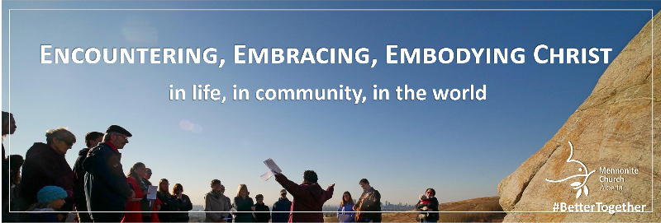
Sept. 27, 2020: E3 Celebration and Commitment Service
Background
Mennonite Church Alberta’s Vision 2020 process of discernment and renewal has resulted in a 3-year action plan called,
“Encountering, Embracing Embodying Christ…In Life, in Community, in the World.”
On September 27 we as MCA would like each congregation to devote its worship service to a time of mutual commitment and celebration of Year 1 of this action plan: How might we as individuals and congregations open ourselves to more fully Encounter, Embrace, Embody Christ…in Life? How might we celebrate Christ’s presence and our mutual calling to connect more closely to Christ as individuals, as congregations, and as a broader church family?
What is E3?
Through the two year Vision 2020 process we heard God calling us into a deeper relationship with God and each other. We heard a longing for a deep and real relationship where God's love flows to, in, and through us.
E3 is a call for each of us to actively pursue a deeper relationship with God. It is an opportunity to explore new (or old) ideas of theology, faith and discipleship. It is also an organic process: The more we open opportunities to “encounter” Jesus, and come to recognize him in our daily lives, the more we learn to “embrace” God’s love and kingdom ways; and the more we embrace God’s love and Jesus’ teaching, the more we are empowered and inspired to “embody” that which is real and true to us.
To find out more about the E3 process, the 3-year plan, and the many resources available—including PowerPoint slides and notes from the sessions of Vision 2020—take some time to explore the MCAB website: https://mcab.ca/e3-mca
Common Action of Commitment and Celebration
- As part of the Sept 27 service, we invite each church to provide an opportunity for people to reflect on a commitment they would like to make toward incorporating a new spiritual practice into their life.
- We also encourage people to celebrate ways they have already experienced “encountering, embracing, embodying Christ in life”.
- Below are some visual images congregations can use to assist with the expression of individuals’ commitment or reflection in the context of the whole Mennonite Church Alberta.
- See the Worship Service Outline for more ideas about this aspect of the service, including how people can share their thoughts in person or online, including through an MCA form.
Common Visual
- We invite each congregation to use the accompanying tree image to represent our MCA family.
  - As the larger church, we are connected in Christ to each other for support and nourishment like the trunk and branches of a tree.
  - The leaves represent individuals within our congregations across Alberta.
  - Spiritual disciplines and prayer practices help grow the roots of encountering, embracing, and embodying Christ that nourish an ever-growing, enlarging, flourishing tree of the kingdom.
- During the Service on Sept 27
  - The tree visual provides a focus of the connection we share together. It can be shown electronically for electronic service options, printed as a handout, or displayed on a wall for in-person worship.
  - Each person is encouraged to use the leaf graphic to record a commitment, reflection, or experience of encountering, embracing, embodying Christ. Leaves can be printed by individuals at home or by the church office. These can either be kept as a reminder or contribute to a larger congregational display.

- We suggest each congregation set up a display of this tree image in their church building.
  - Prepare a wall or bulletin board in the church with a physical image of the tree image. Since the beginning of the covid-19 pandemic we have been largely disconnected from each other. Having a physical focus in our church buildings provides a tangible point of connection.
  - People could bring their leaves to their church buildings during the week following the Sept 27 service, and add them to the leaves of the physical display of the tree. Many people have not entered their church buildings since March. Providing a safe way to do so would give people a chance to feel physically connected. Safety measures, including ensuring people arrive at different times, masks, providing hand sanitizer upon entry, etc. would need to be taken. Guidance on church gatherings, including provincial requirements, can be found through https://mcab.ca/
  - Congregations may decide utilize this tree and leaf image in other ways, such as compiling people’s reflections and having one person write them on leaves to be placed on the tree display.
  - If possible, please provide MCA with short video clips or pictures of people adding their leaves and the growing tree visual. These will be compiled into a video to share with each other.

To do before Sept. 27th:
- Right away:
  - Look through the accompanying Worship Service Outline for the September 27 worship service. See which of the resources will fit your congregation. Including the common celebration, commitment, and prayer items from this outline will enhance the common connection we share with each other.
  - Provide your congregation with background information about our E3 theme:
    - Use resources from the MCA E3 Webpage https://mcab.ca/e3-mca such as:
      - A bulletin insert giving background information on Vision 2020 and E3
      - A brochure summarizing Vision 2020, E3, and “where we go from here”
      - A letter from the past spring about the E3 process.
      - Videos of reflections from Caleb Kowalko, Tany Warkentin, and Tim Wiebe-Neufeld
      - Written thoughts by the E3 Reference Group
      - A letter inviting MCA Congregations to dedicate Sept 27 to
    - Encourage everyone to explore the E3 Webpage themselves, https://mcab.ca/e3-mca.

- Sept. 13th and 20th:
  - Watch for an MCA bulletin insert to use during these two Sundays.
  - Promote the Sept 27 E3 Worship Service
  - Ask congregants to prepare by considering one action they could incorporate into their life to open themselves to encounter, embrace, and embody Christ. Some ideas can be found on the bulletin insert or bucket lists on the MCA site (https://mcab.ca/e3-mca). Encourage your congregants to consider expressing their commitment as part of the Sept 27 service.
  - Share with congregants that there will also be the opportunity to celebrate experiences we have had of encountering, embracing, and embodying Christ in life.

We thank you for your role in helping your congregation explore “encountering, embracing, and embodying Christ” in our lives. We trust this will be a meaningful time of commitment and celebration as we join with our Faith Family from across Alberta in going deeper into our relationship with Christ and seeing how we will change because of it!
The E3 Reference Group:
Debbie Baergen, First Mennonite Edmonton Werner DeJong, Holyrood Mennonite Laura Wiebe, Trinity Mennonite Tim Wiebe-Neufeld, MCA Executive Minister

